MOHAN SAI PRAGADA

mohansai.pragada2019@vitstudent.ac.in

Assignment-5:

Create a web dashboard to take user input for scheduling the pump controller (date & time). store the data in the Cloudant DB.

Software: IBM

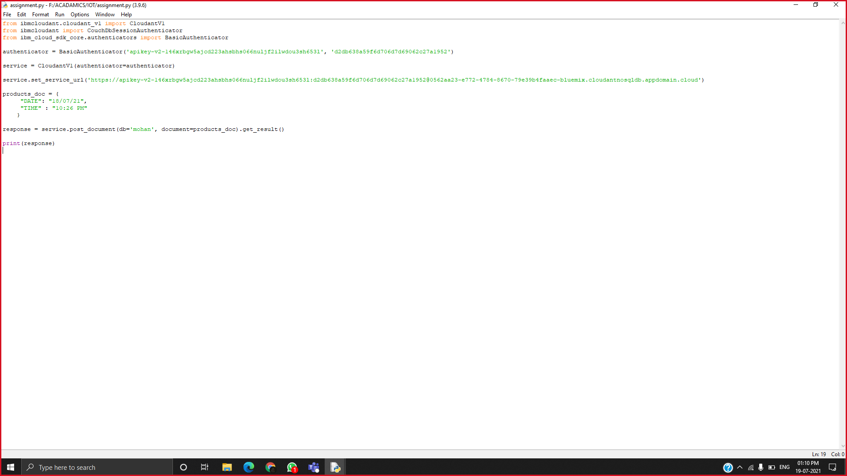**Code:**

Here, BasicAuthenticators are username & password of Cloudant DB

We need to store the time and date in the cloudant DB

**CREATION OF DB:**

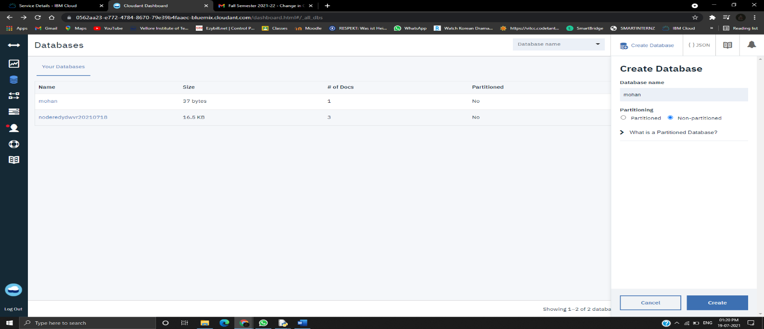

After the code execution we can view the data in the cloudant DB

